# **CTF Topic: OSI Model**

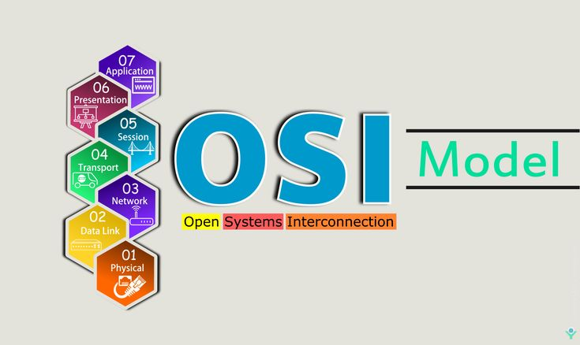

# **Introduction**

The OSI (Open Systems Interconnection) Model is a conceptual framework that standardised the functions of a telecommunication or computing system into seven distinct layers. Each layer has specific responsibilities in facilitating communication between devices over a network.

# **Why the OSI Model is Needed**

The OSI Model provides a structured approach to network communication, allowing for interoperability between different devices and systems from various manufacturers. It also aids in troubleshooting network issues by dividing complex networking processes into manageable layers.

# **Why the OSI Model is Needed**

Implementing the OSI Model involves understanding the functions and interactions of its seven layers:

1. **Physical Layer**: Deals with the physical transmission of data, such as electrical signals or optical signals, over the network medium.
2. **Data Link Layer**: Ensures reliable point-to-point and point-to-multipoint communication by handling error detection and correction at the data frame level.
3. **Network Layer**: Manages logical addressing, routing, and packet forwarding to enable data exchange between different networks.
4. **Transport Layer**: Provides end-to-end communication by segmenting and reassembling data, ensuring reliable and error-checked delivery.
5. **Session Layer**: Establishes, maintains, and terminates sessions or connections between applications on different devices.
6. **Presentation Layer**: Handles data translation, encryption, and compression to ensure compatibility between different systems.
7. **Application Layer**: Supports end-user applications and services, facilitating interactions between users and network resources.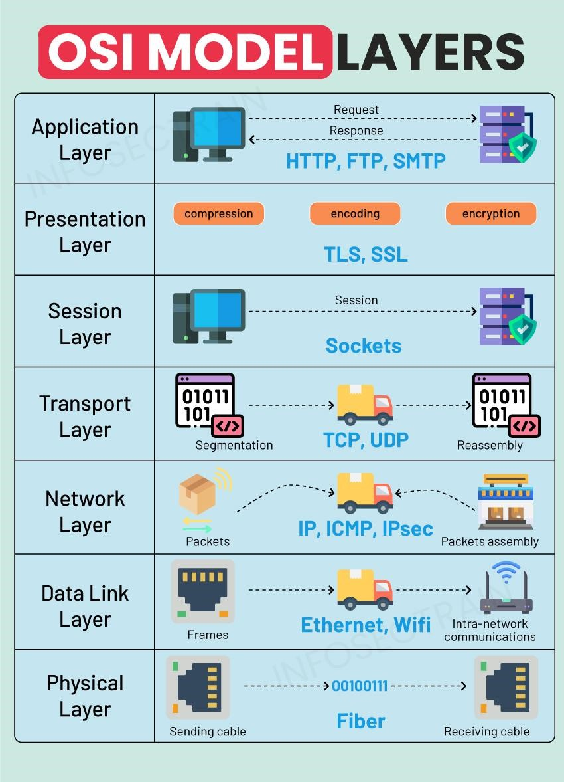

# **Let’s start the Challenge**

# **Question**

Flag1: How many layers are in the OSI Model?

Answer: Seven or 7

Flag Captured

Flag 2: Which layer handles logical addressing?

Answer: Network Layer

Flag Captured

Flag3: Presentation Layer handles in translation of ?

Answer: Data

Flag Captured

Flag 4: Which layer deals with electrical signals?

Answer: Physical Layer

Flag Captured

Flag 5: Which layer manages sessions?

Answer: Session Layer

Flag Captured